STUDENT ATTENDANCE MANAGEMENT SYSTEM
Cornerstone project work submitted to Aditya University in partial fulfilment of the
requirements for the award of the Degree of
B.Tech. degree
in
Artificial Intelligence and Machine Learning (2026-2027)
Object Oriented Programming through C++ (2501CS08)
TEAM NUMBER – 02
SUBMITTED BY
PADIMI MOKSHAGNA 25B11AI860
ALLADA RAM CHARAN TEJA 25B11AI103
VANAMADI RAMA VENKATA PAVAN 25B11AI357
MUDAVATHU MAHESH 25B11AI027
UNDER THE GUIDANCE OF
T.VIJAYALAKSHMI, M.Tech
ASSISTANT PROFESSOR
AIML DEPARTMENT
Department of Artificial Intelligence and Machine Learning
Aditya University, Aditya Nagar, ADB Road,
Surampalem, Kakinada District, Andhra Pradesh, India - 533437


DEPARTMENT OF ARTIFICIAL INTELLIGENCE AND MACHINE LEARNING
ADITYA UNIVERSITY, ADITYA NAGAR,
SURAMPALEM.
CERTIFICATE
This is to certify that the cornerstone project entitled “QUIZ GAME SYSTEM” is being submitted by PADIMI MOKSHAGNA 25B11AI871, ALLADA RAM CHARAN TEJA 25B11AI037, VANAMADI RAMA VENKATA PAVAN 25B11AIC29 and MUDAVATHU MAHESH 25B11AI764 in partial fulfilment for the award of B. Tech Degree from Aditya University, is a record of original work done by them under my supervision. The contents of this project, in full or in parts, have not been submitted to any other Institute or University for the award of any degree or diploma.

Project Guide
T.VIJAYALAKSHMI, M.Tech ,
Assistant Professor
Department of CSE
Aditya University

DECLARATION
We hereby declare that the Cornerstone project work entitled “STUDENT ATTENDANCE MANAGEMENT SYSTEM” is being submitted by us for the award of the B. Tech Degree in Artificial Intelligence and Machine Learning, Aditya University, Aditya Nagar, ADB Road, Surampalem, and is a record of original work carried out by us. We further declare that this project work has not been submitted, either in full or in part, for the award of any degree or diploma in this or any other institution. We also confirm that this work has been carried out with academic honesty and complies with the Institutional Academic Integrity and AI Usage Policy.

Submitted By
PADIMI MOKSHAGNA 25B11AI860
ALLADA RAM CHARAN TEJA 25B11AI103
VANAMADI RAMA VENKATA PAVAN 25B11AI357
MUDAVATHU MAHESH 25B11AI027

Place: Surampalem
Date: ____________________

ACKNOWLEDGEMENT
It is with immense pleasure that we express our sincere gratitude to our Cornerstone Project Guide, , T.VIJAYALAKSHMI, M.Tech ,Assistant Professor, who has guided us throughout the project. Valuable support, encouragement, and guidance have greatly contributed to the successful completion of this work.
We would like to thank our Deputy Heads of the Department, Dr. R. Suneetha, Assistant Professor, Dr.Bollu Manikyala Rao, Associate Professor ,Dr.D.Veeraswamy,Assistant Professor Department of AIML, for their support and valuable suggestions.

Our deepest thanks to our Head of the Department Dr. . K.Naga Bhargavi, Associate Professor,
for her inspiration and for providing all the necessary facilities and resources required for this project.

We also extend our sincere thanks to Dr. M.V. Rajesh, Associate Dean, School of Computing for their encouragement and support during the course of our project.
We would like to express our sincere gratitude to Dr. G. Suresh, Registrar, Dr. A Ramesh, Pro Vice-Chancellor (Engineering & Sciences), Dr.S. Rama S r e e , Pro Vice-Chancellor (Academics), D r . M.B. Srinivas, V i c e -Chancellor, Dr. M. Sreenivasa Reddy, Deputy Pro Chancellor and Management, Aditya University for providing excellent infrastructure and state-of-the-art laboratories.
Finally, we would like to thank the faculty members, lab technicians, non-teaching staff, and our friends who have directly or indirectly supported us in completing this Cornerstone project successfully

PADIMI MOKSHAGNA 25B11AI860
ALLADA RAM CHARAN TEJA 25B11AI103
VANAMADI RAMA VENKATA PAVAN 25B11AI357
MUDAVATHU MAHESH 25B11AI027
Date: ____________________

ABSTRACT
The Quiz Game System is a menu-driven C++ console application designed to conduct multiple-choice quizzes on different topics. The program asks the player to enter a name and select a topic such as C++, General Knowledge (GK), Science or Mathematics. Questions, four answer options and the correct-answer number are stored in an external CSV file named questions.csv. The program reads the file using file handling, separates each row into fields and stores the questions in a vector.
During the quiz, the system displays questions matching the selected topic, accepts an answer from 1 to 4, validates the input range and compares the selected option with the stored correct answer. It counts correct answers and calculates the final score, percentage and grade. The player can choose to play again and select another topic.
The project demonstrates structures, functions, vectors, strings, loops, conditional statements and file handling in C++. Since questions are stored separately in a CSV file, the question bank can be updated without editing the main C++ source code, provided the CSV format is maintained.

ABBREVIATIONS
Abbreviation | Meaning
C++ | C++ Programming Language
CSV | Comma-Separated Values
I/O | Input / Output
OOP | Object-Oriented Programming
PBL | Project-Based Learning
MCQ | Multiple-Choice Question

LIST OF FIGURES
Figure No. | Title
Figure 1 | Overall System Architecture
Figure 2 | Question Structure and Data Organization
Figure 3 | Overall Quiz Game Flowchart
Figure 4 | Question Loading from CSV File
Figure 5 | Topic Selection and Quiz Execution Flow
Figure 6 | Answer Validation and Evaluation Flow
Figure 7 | Score, Percentage and Grade Calculation
Figure 8 | Main Menu and Topic Selection Output
Figure 9 | Multiple-Choice Question Display
Figure 10 | Correct and Wrong Answer Output
Figure 11 | Final Result Display
Figure 12 | Play Again and Program Exit Output

LIST OF TABLES
Table No. | Title
Table 1 | Planned Modules and Functions
Table 2 | Programming Concepts Used in the Project
Table 3 | Structure Members and Their Purpose
Table 4 | Quiz Input and Output Details
Table 5 | Grade Calculation Rules
Table 6 | Test Cases and Expected Results
Table 7 | Team Members and Responsibilities

TABLE OF CONTENTS
Section | Title
Chapter 1 | Project Planning
1.1 | Problem Statement
1.2 | Project Objectives
1.3 | Planned Modules
1.4 | System Architecture and Flowchart
Chapter 2 | Project Implementation
2.1 | Programming Concepts Used
2.2 | Code Explanation
2.3 | Input and Output Screens
2.4 | Test Cases
Chapter 3 | Conclusion and Future Scope
3.1 | Conclusion
3.2 | Future Scope
— | References
— | Appendix: Team Responsibilities

CHAPTER 1
PROJECT PLANNING

1.1 Problem Statement

Conducting quizzes manually requires a person to prepare questions, display answer options, check responses and calculate scores. This process can take time and may result in errors during answer evaluation and score calculation.

When questions are directly written inside the program, adding or modifying questions may also require changes to the source code.

The Quiz Game System addresses these problems by providing a menu-driven application that automatically displays questions, evaluates answers and calculates results. The questions are maintained in an external CSV file, making the question bank easier to modify without changing the main program logic.

1.2 Project Objectives

The main objectives of the Quiz Game System are:

To develop a simple quiz application using C++.

To allow players to enter their names.

To provide multiple quiz topics.

To read questions and options from a CSV file.

To display four options for every question.

To validate the player's answer choice.

To evaluate answers automatically.

To calculate the final score and percentage.

To assign a grade based on the percentage.

To allow players to attempt another quiz.

1.3 Planned Modules
The project is organized into the following modules.
Module | Functionality | Main code element
Player Module | Accepts the player's name. | main()
Topic Selection Module | Allows the player to choose a topic. | Topic selection in main()
Question Bank Module | Loads questions from the CSV file. | loadQuestions()
Quiz Module | Displays questions and options. | startQuiz()
Answer Evaluation Module | Validates and checks answers. | Answer input and comparison
Result Module | Calculates score, percentage and grade. | Result calculation in startQuiz()
Replay Module | Allows the player to play again. | do-while loop in main()

These are logical modules implemented through functions and code blocks in the current program.
1.4 System Architecture and Flowchart
1.4.1 System Architecture
The system can be understood through three logical layers.
1. Presentation Layer
This layer interacts with the player through the console. It displays menus, questions, options, feedback and final results using cout, and accepts inputs using cin.
2. Program Logic Layer
This layer performs topic selection, question filtering, answer validation, answer checking, score calculation and grade assignment.
3. Data Layer
The external file questions.csv stores the question bank. The program reads the file and stores the questions in a vector<Question> while it runs.
The current implementation does not use a database or online API.
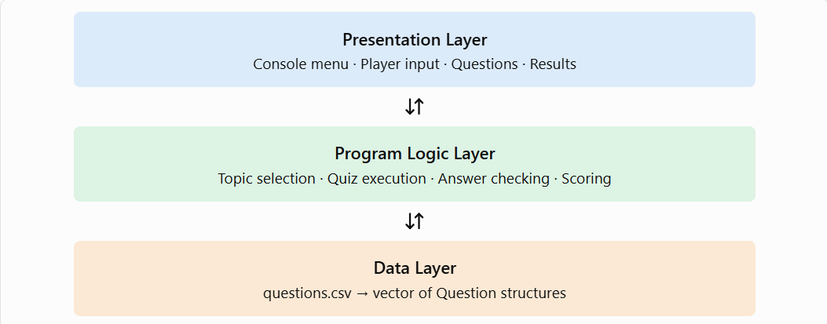
Figure 1 – Overall System Architecture

1.4.2 Overall Processing Flow

The program starts by loading questions from questions.csv. If the questions are loaded successfully, it asks for the player's name and displays the topic menu. After the player selects a topic, the system displays the relevant questions, checks the answers and calculates the result. Finally, the player can choose to play again or exit.
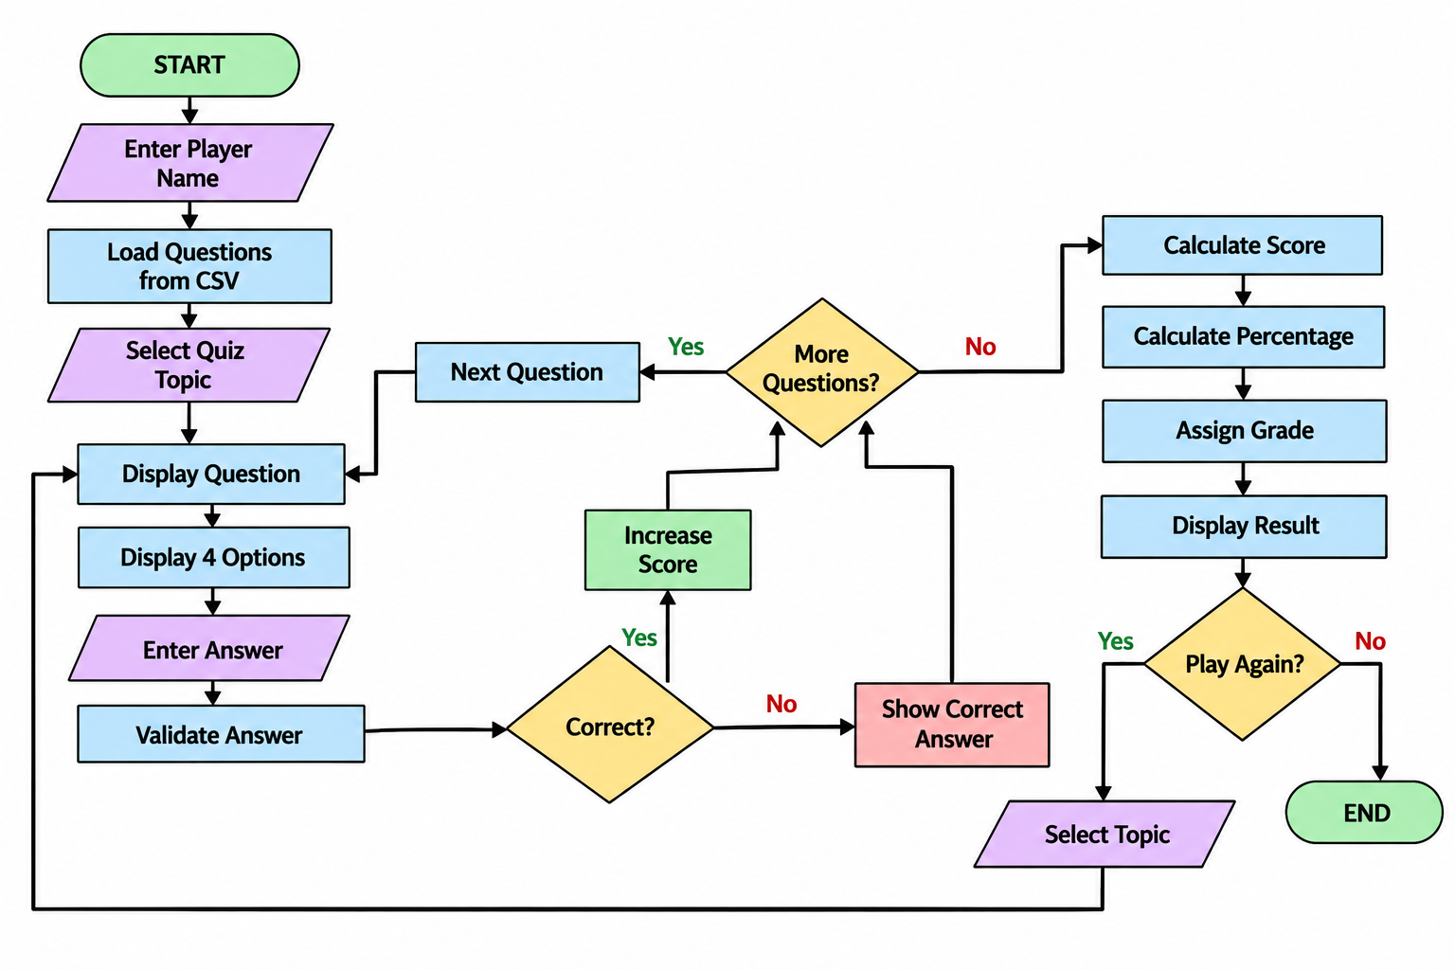
Figure 3 – Overall Quiz Game Flowchart

1.4.4 Quiz Execution Algorithm
- Receive the selected topic.
- Initialize the score and total question count to zero.
- Read each question from the vector.
- Skip questions that do not match the selected topic.
- Display the question and four options.
- Accept and validate the answer from 1 to 4.
- Compare the answer with the stored correct answer.
- Increase the score if the answer is correct.
- Repeat until all matching questions are processed.
1.4.5 Result Calculation Algorithm
- Check whether any questions were available for the selected topic.
- Calculate the percentage using the score and total number of questions.
- Assign a grade based on the percentage.
- Display the score, percentage and grade.
- Return control to the replay section in main().
The percentage formula is:
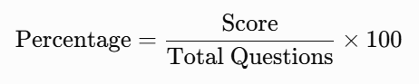
Grade Calculation Rules
Percentage | Grade
90% and above | A
75% to below 90% | B
60% to below 75% | C
40% to below 60% | D
Below 40% | F

CHAPTER 2
PROJECT IMPLEMENTATION

2.1 Programming Concepts Used
Concept | Application in the project
Structure | Groups related question details into Question.
Functions | Separates question loading and quiz execution.
Vector | Stores multiple question records in memory.
File handling | Reads question data from questions.csv.
String handling | Processes the question text and options.
Loops | Repeats question processing and validates input.
Conditional statements | Checks topics, answers and grades.
Input/output | Uses cin and cout for interaction.
Type conversion | Uses atoi() to convert the correct answer into an integer.

Figure 2 -Question Structure and Data Organization
2.2 Code
2.2.1 Question Structure

The struct Question defines the format of a question. It stores the topic, question text, four answer options and the correct-answer number. This allows all the information for one question to be grouped into a single record.
2.2.2 loadQuestions() Function
This function reads questions from the external CSV file.
- ifstream opens the file for reading.
- getline() reads each line and separates the fields.
- stringstream processes a row by splitting it at commas.
- atoi() converts the correct-answer text into an integer.
- push_back() adds the completed question to the vector.
The function returns the vector containing the loaded questions.

2.2.3 startQuiz() Function

This function conducts the quiz for the selected topic.

It initializes the score and total question count, checks each question's topic and displays only matching questions. It then displays four options and accepts the player's answer.

If the answer is between 1 and 4, the program compares it with the correct-answer number. Correct answers increase the score, while incorrect answers display feedback and the stored correct-answer number.

After all matching questions are processed, the function calculates the percentage and grade and displays the final result.

2.2.4 main() Function

The main() function controls the overall execution of the program.

It loads the questions, checks whether the question bank is empty, accepts the player's name and displays the topic menu. The selected number is converted into a topic name, and startQuiz() is called to conduct the quiz.

The do-while loop allows the player to play again without restarting the application.

2.2.5 File Handling

The question bank is stored in questions.csv, separately from the C++ source file. Its columns are:

Topic, Question, Option1, Option2, Option3, Option4, CorrectAnswer

The program reads the CSV file when it starts. This means questions can be added or modified by editing the file while keeping the same format.

Current limitation: The program does not save player scores to a separate file. The score is calculated and displayed during the quiz.

2.2.6 Program Data Flow
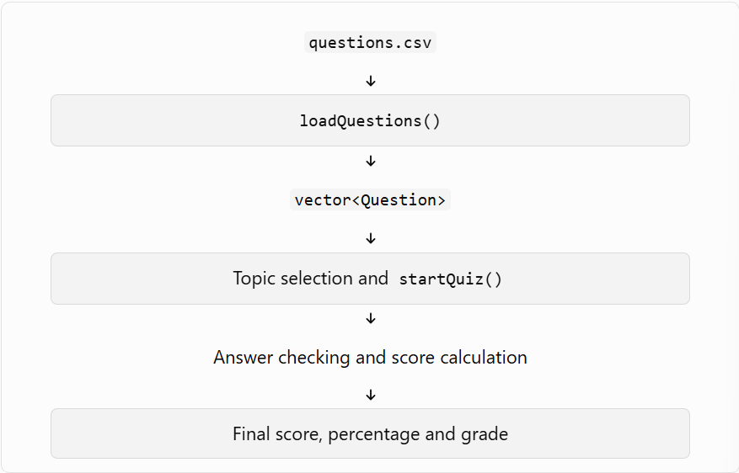
Source Code:
#include <iostream>
#include <fstream>
#include <sstream>
#include <vector>
#include <string>
#include <cstdlib>
using namespace std;

// Structure to store one question
struct Question
{
string topic;
string question;
string option1;
string option2;
string option3;
string option4;
int correctAnswer;
};

// Read questions from CSV file
vector<Question> loadQuestions()
{
vector<Question> questions;

ifstream file("questions.csv");
string line;

// Skip the first row (column names)
getline(file, line);

while (getline(file, line))
{
stringstream ss(line);
string data;
Question q;

getline(ss, q.topic, ',');
getline(ss, q.question, ',');
getline(ss, q.option1, ',');
getline(ss, q.option2, ',');
getline(ss, q.option3, ',');
getline(ss, q.option4, ',');

getline(ss, data, ',');
q.correctAnswer = atoi(data.c_str());

questions.push_back(q);
}

file.close();

return questions;
}

// Start the quiz
void startQuiz(vector<Question> questions, string topic)
{
int score = 0;
int total = 0;

cout << "\n====================================\n";
cout << " " << topic << " QUIZ\n";
cout << "====================================\n";

for (int i = 0; i < questions.size(); i++)
{
Question q = questions[i];
// Show only selected topic
if (q.topic != topic)
continue;

total++;

cout << "\nQuestion " << total << ": " << q.question << endl;
cout << "1. " << q.option1 << endl;
cout << "2. " << q.option2 << endl;
cout << "3. " << q.option3 << endl;
cout << "4. " << q.option4 << endl;

int answer;

// Input validation
while (true)
{
cout << "Enter your answer (1-4): ";
cin >> answer;

if (answer >= 1 && answer <= 4)
break;

cout << "Invalid choice! Please enter 1 to 4.\n";
}

if (answer == q.correctAnswer)
{
cout << "Correct!\n";
score++;
}
else
{
cout << "Wrong!\n";
cout << "Correct answer: " << q.correctAnswer << endl;
}
}

if (total == 0)
{
cout << "\nNo questions found for this topic.\n";
return;
}

// Calculate percentage
float percentage = (float)score / total * 100;

// Calculate grade
char grade;

if (percentage >= 90)
grade = 'A';
else if (percentage >= 75)
grade = 'B';
else if (percentage >= 60)
grade = 'C';
else if (percentage >= 40)
grade = 'D';
else
grade = 'F';

// Display result
cout << "\n====================================\n";
cout << " RESULT\n";
cout << "====================================\n";

cout << "Score : " << score << "/" << total << endl;
cout << "Percentage : " << percentage << "%" << endl;
cout << "Grade : " << grade << endl;

cout << "====================================\n";
}

// Main function
int main()
{
// Load questions from CSV
vector<Question> questions = loadQuestions();

if (questions.empty())
{
cout << "Unable to load questions.csv\n";
cout << "Make sure the CSV file is in the same folder as the program.\n";
return 0;
}
string name;
cout << "====================================\n";
cout << " QUIZ GAME SYSTEM\n";
cout << "====================================\n";
cout << "Enter your name: ";
getline(cin, name);

char again;

do
{
int choice;

cout << "\nHello " << name << "!\n";
cout << "\nSelect a Quiz Topic:\n";
cout << "1. C++\n";
cout << "2. GK\n";
cout << "3. Science\n";
cout << "4. Mathematics\n";

while (true)
{
cout << "Enter your choice (1-4): ";
cin >> choice;

if (choice >= 1 && choice <= 4)
break;

cout << "Invalid choice! Please try again.\n";
}

string topic;

if (choice == 1)
topic = "C++";
else if (choice == 2)
topic = "GK";
else if (choice == 3)
topic = "Science";
else
topic = "Mathematics";

// Start quiz
startQuiz(questions, topic);

cout << "\nDo you want to play again? (Y/N): ";
cin >> again;

} while (again == 'Y' || again == 'y');

cout << "\nThank you for playing, " << name << "!\n";

return 0;
}

2.3 Input and Output Screens
Inputs
- Player name
- Quiz topic selection
- Answer number from 1 to 4
- Replay choice (Y or N)
Outputs
- Topic selection menu
- Questions and four answer options
- Correct or wrong answer messages
- Score and total questions
- Percentage and grade
- Invalid input messages
- Thank-you message at program exit
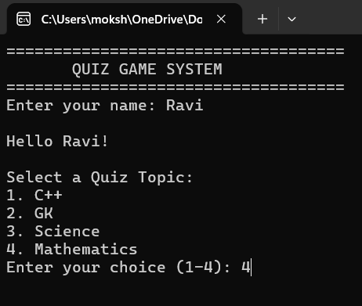
Figure 8 – Main Menu and Topic Selection Output

. 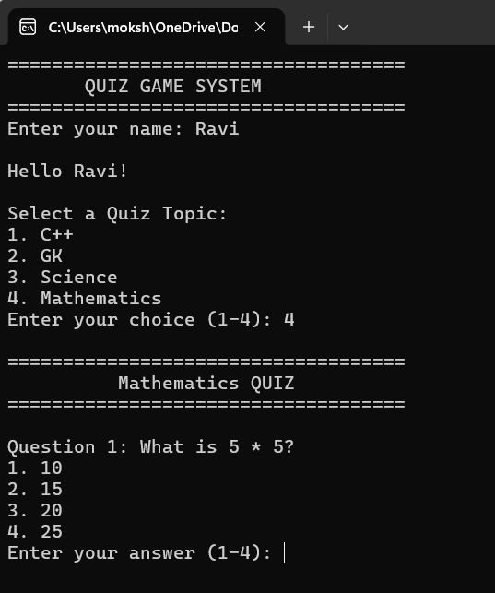
Figure 9 – Multiple-Choice Question Display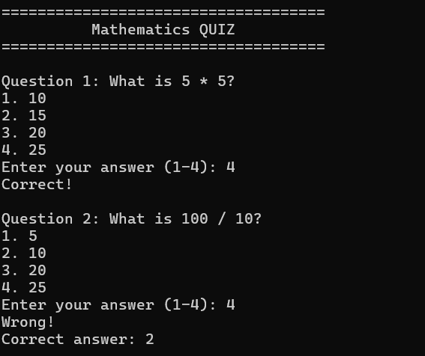
Figure 10 - Correct and Wrong Answer Output
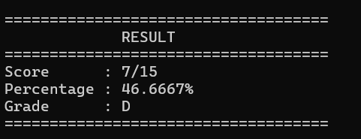
Figure 11 – Final Result Display
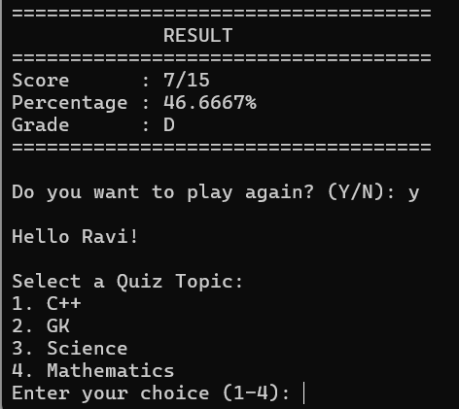
Figure 12 – Play Again and Program Exit Output

2.4 Test Cases
No. | Test Case | Input/Condition | Expected Result
1 | CSV file loads | Valid questions.csv | Questions load into the vector.
2 | Missing question file | File unavailable | Error message is displayed.
3 | Topic Selection | Select Science | Only Science questions are displayed.
4 | Correct answer | Enter the correct option number | Correct message and score increment.
5 | Wrong answer | Enter a different valid option | Wrong message and correct-answer number displayed.
6 | Invalid answer | Enter 0 or 5 | Program asks for a valid answer from 1 to 4.
7 | Percentage calculation | 8 correct out of 10 | 80% and grade B.
8 | Replay | Enter Y or y | Topic menu is displayed again.
9 | Exit | Enter N or n | Thank-you message is displayed.

CHAPTER 3 — CONCLUSION AND FUTURE SCOPE

3.1 Conclusion

The Quiz Game System demonstrates the development of a simple interactive quiz application using C++. It allows players to select topics, answer multiple-choice questions and receive automatic evaluation.

The system reads question data from an external CSV file, validates answer choices and calculates the score, percentage and grade. It uses structures, functions, vectors, strings, loops, conditional statements and file handling.

Separating the question bank from the program logic makes it easier to maintain and update quiz content. The project provides practical experience in C++ programming and the development of a menu-driven application.

3.2 Future Scope

The system can be enhanced in the following ways:

Add a timer for each question.

Randomize the order of questions and options.

Store player scores and quiz history in a file or database.

Introduce difficulty levels such as Easy, Medium and Hard.

Add more quiz topics.

Display the correct option text after an incorrect answer.

Develop a graphical user interface.

Add player profiles and a leaderboard.

Provide an administrator option to manage questions.

REFERENCES

B. Stroustrup, The C++ Programming Language, 4th Edition, Addison-Wesley, 2013.

E. Balagurusamy, Object-Oriented Programming with C++, McGraw Hill Education.

C++ Reference — https://en.cppreference.com

Course material: Object Oriented Programming through C++, Aditya University.

APPENDIX — TEAM MEMBERS AND RESPONSIBILITIES
Team member | Role / responsibility
Padimi Mokshagna (Team Leader) | Project planning, overall integration, core code coordination and presentation.
Mahesh | Problem statement, objectives and planned modules.
Charan | Quiz functionality, answer evaluation and architecture explanation.
Pavan | Flowchart, documentation and test-case preparation.

Update this table if your actual work division differs.

Final submission checklist

Add official roll numbers and team number.

Fill in the project guide's name and designation.

Insert your completed horizontal flowchart under Figure 3.

Add actual program screenshots for Figures 8–12.

Verify the page numbers after arranging the document.

Ensure that the code and documentation describe the same implemented features.

